CLE ELUM SECTOR

The Cle Elum Sector includes the town of Cle Elum, north of the Yakima river, extending east to (and including) White Rd. off Airport Rd., and extending east on First St. to (but not including) the SR-970 exit from I-90.

Note that this sector includes the Hanson Ponds south of I-90, accessible by taking Oaks Rd. across I-90 and turning left just past the entrance ramp to I-90 Eastbound, as well as the NP Railroad Ponds off Charter Rd. just south of I-90 as you head towards South Cle Elum.

The Coal Mines trail should be walked as far as the circle's edge: about a mile and a quarter. There are bird feeders at the house at the end of Denny Way; there is a spur from the Coal Mines trail that connects to Denny and provides an ideal place to view the feeders.

If snow conditions permit, the upper portions of Cle Elum should be investigated. This includes specifically Summit View Rd.
CLE ELUM SECTOR MAP
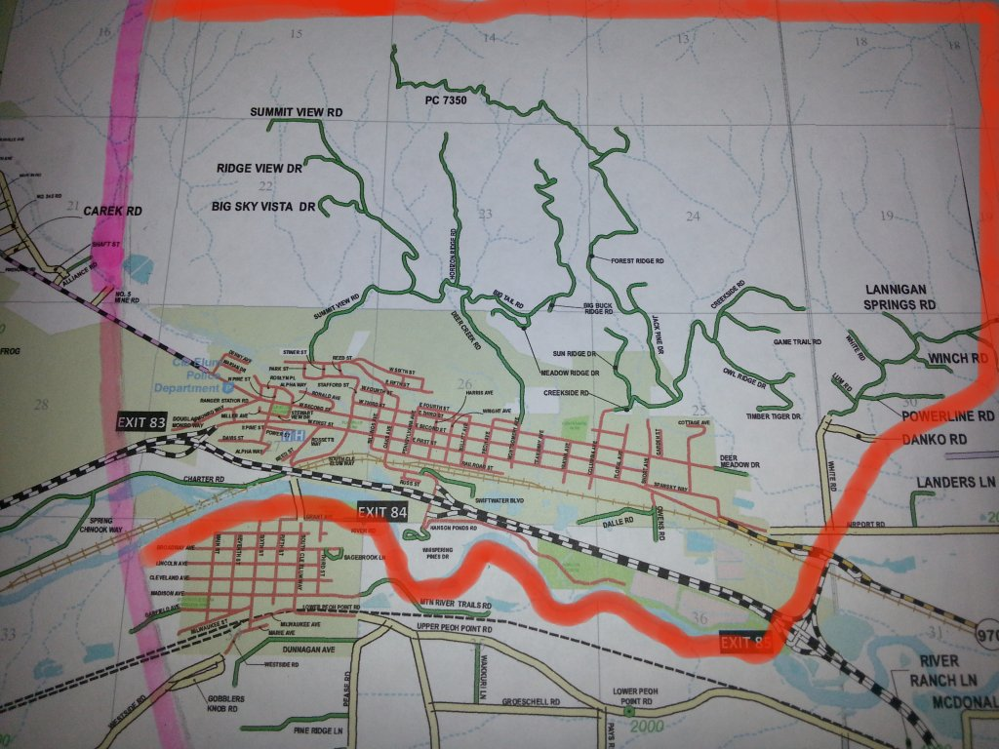
SOUTH CLE ELUM SECTOR

The South Cle Elum Sector comprises South Cle Elum, including everything south of the river and west of the point where Upper Peoh Point Rd. crosses over I-90 and becomes Thorp Prairie Rd.

Obviously, this includes all of "downtown" South Cle Elum, where houses with bird feeders or with fruit-covered trees should be sought out.

The Iron Horse Trail could be walked from the west edge of the circle as far east as a bit past McDonald Rd.

McDonald Pond and surrounding areas can be quite good, especially if partially unfrozen.

The large development up Casassa Rd. should be covered well.
SOUTH CLE ELUM SECTOR MAP
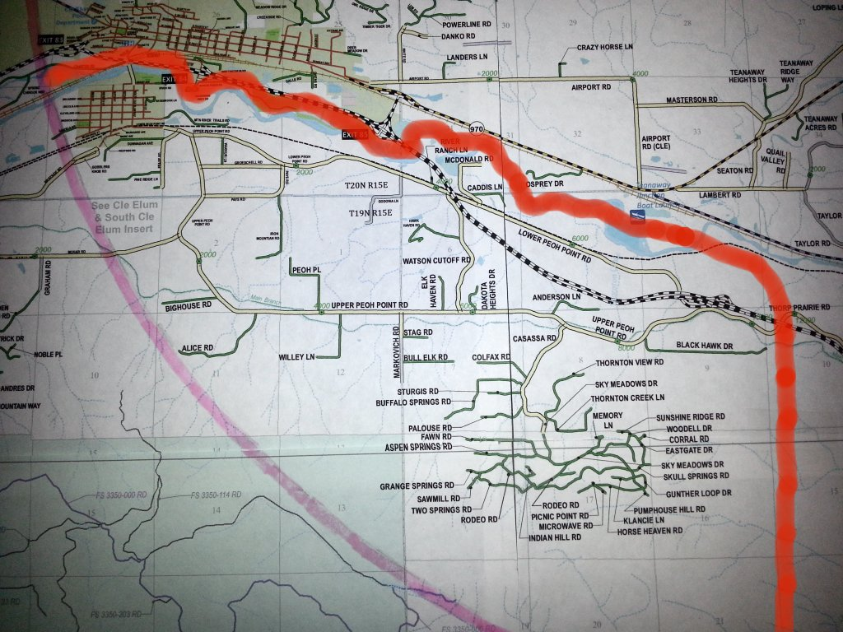
IRON HORSE TRAIL ROUTE

The Iron Horse Trail accesses areas otherwise inaccessible, including the lower reaches of the Yakima River. It could be walked, or traversed using cross-country skis or snowshoes. Because there is no access to the trail anywhere near the east edge of the circle, it has to be done as an out-and-back.

Access is from the school bus turnaround on Lower Peoh Pt. Rd., a little east of McDonald Rd. Make sure you park as tucked-away as you can in the turnaround, so as not to block busses or snowplows. (Officially, parking is only allowed there from something like 8:30-3:30 and you may be starting a touch early and finishing a touch late). We've usually only get 4-5 miles in before having to turn around due to time. The first mile is usually the best, though there are other good spots further on (and some stretches that tend to add little). Ruffed Grouse can usually be found low in willows etc. on the north slope of the first mile of the trail. Sometimes they are on the slope between the trail and the river.
IRON HORSE SECTOR MAP
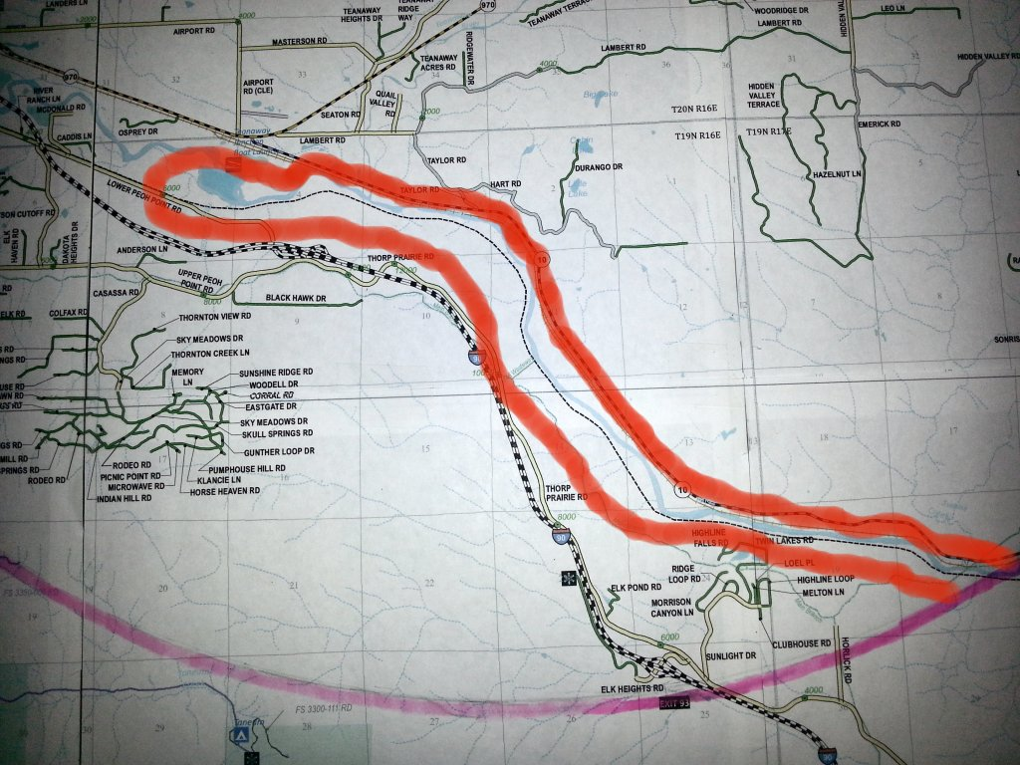

SOUTHEAST SECTOR

Everything accessible from the Elk Heights exit off I-90, including Thorp Prairie Rd. west to I-90, the L.T. Murray, and the Sunlight Waters development. Care must be used as the exit is very close to the edge of the circle.

Then, cross over to SR-10, (via Thorp Prairie Rd heading SE from the interchange, to E Taneum Rd, to N Thorp Highway all outside the circle).

Immediately after getting back into the circle from the southeast on SR-10, we have access into Swauk Ranch (formerly known as Tang Ranch, which is partially owned/controlled by the Nature Conservancy). This can be a walk-in, or you can drive in to the buildings using the gate code.

This sector also includes all of SR-10 to (but not including) Taylor Rd. Sightings of birds in the Yakima River from SR-10 should be crosschecked with the Iron Horse sector team.

Note that the Iron Horse sector lies almost entirely within the Southeast Sector.
SOUTHEAST SECTOR MAP
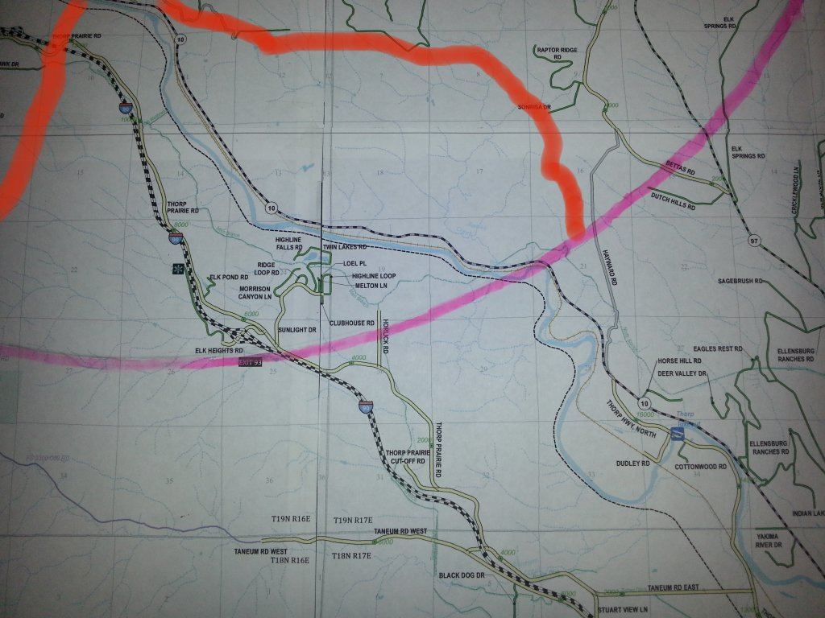

CENTRAL SECTOR

This sector starts with the I-90 rest areas, then the pond at the SR-970 westbound exit, then heading east on SR-970 to the fishing accesses just before SR-10, then SR-10 to the Taylor Bridge, taking Taylor Rd. to Hart Rd., Lambert Rd., Seaton Rd., then WA-970 to the Teanaway Rd., returning on Red Bridge Rd., Masterson Rd., and Airport Rd. (including the Cle Elum Airport), to (but not including) White Rd. This sector borders on every other sector. Care should be taken to note birds on the Hanson Ponds seen from I-90, and generally to coordinate with the all other sectors on sighting near the edges of the sector. Note that both Central and Iron Horse can see the outflow of Teanaway Creek. We need to make sure everything is counted exactly once: not more, and not less.
CENTRAL SECTOR MAP 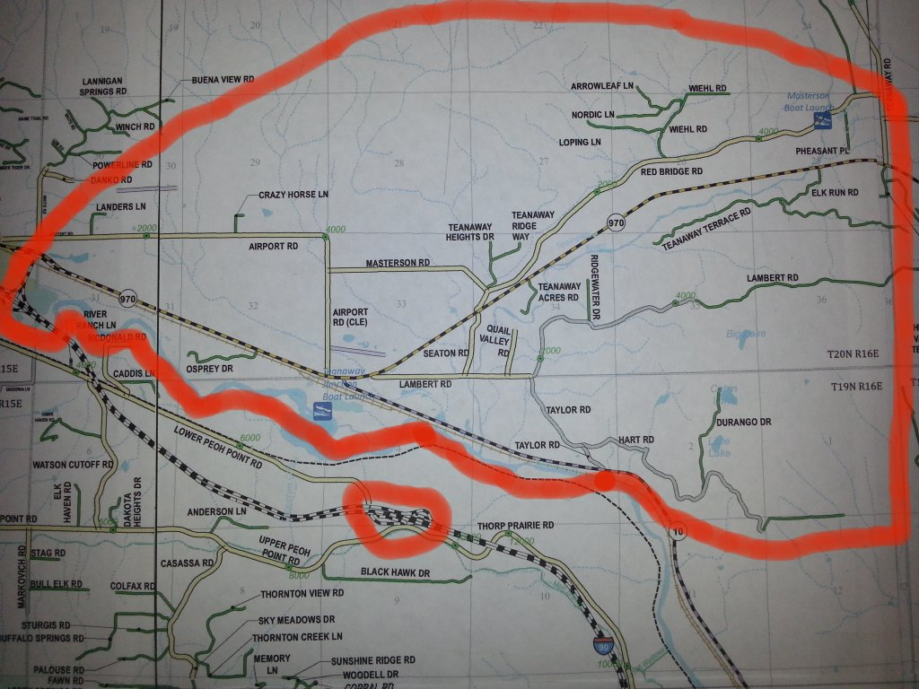

TEANAWAY SECTOR

This sector covers all of Teanaway Rd. (beyond Ballard Hill Rd./Red Brick road), and it’s branches, the North, Middle, and West Forks. Up the Teanaway, the main roads should be plowed quite extensively. Most of the small roads off of the main roads are private and off-limits. Forest Service roads may or may not be passable.

Also included is Ballard Hill Rd., Swauk Cemetery, Swauk Prairie, and Ley Rd., to give the sector a little bit of lower elevation goodness.
TEANAWAY SECTOR NORTH MAP
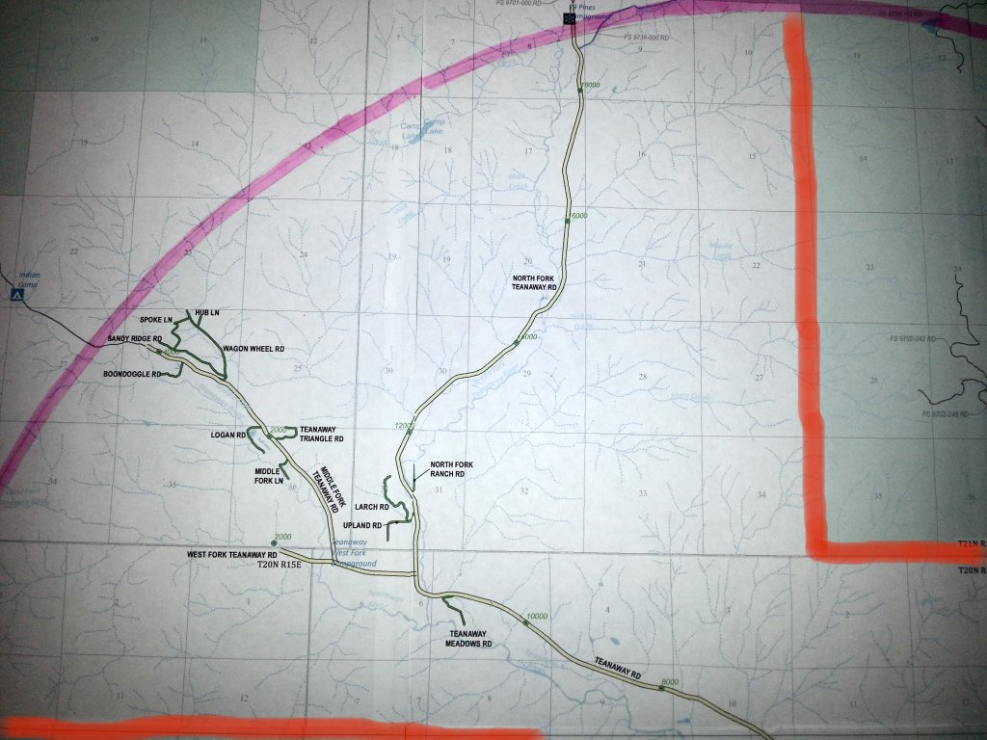
TEANAWAY SECTOR SOUTH MAP
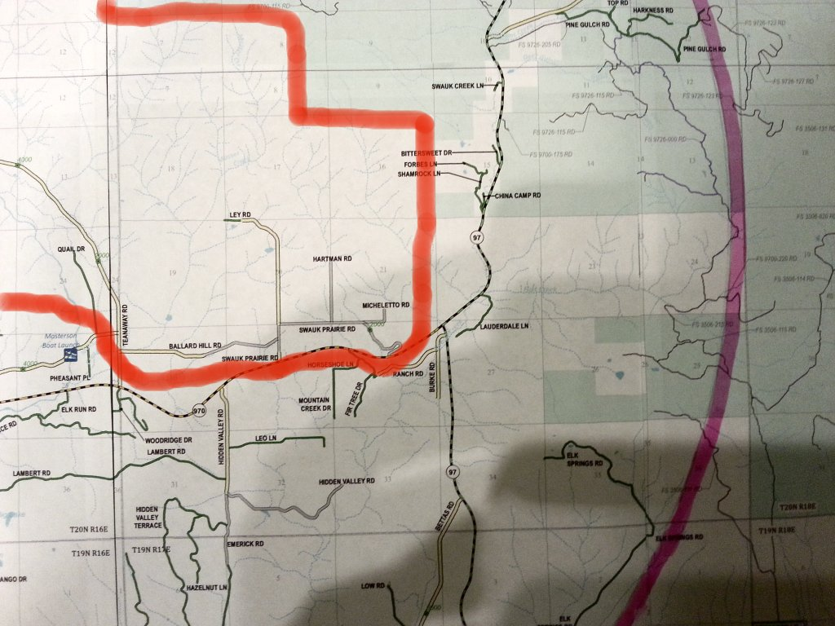
LIBERTY SECTOR

This sector comprises the northeast portion of the circle. It covers everything on the south side of SR-970 beyond the Teanaway Rd. turnoff, and everything accessible off US-97 within the circle.
Specifically, this includes the entire Hidden Valley area, including the westernmost portion of Lambert Rd., all of the fairly extensive road system off Burke Rd., and the Bettas Rd./Hayward Rd. area.

Rather than backtrack, continue on Bettas (not counting birds) to US-97 and turn left. You count again after 0.9 miles on US-97. Take US-97 north past SR-970.

There are a variety of conceivably accessible forest service roads off US-97. Investigate them as you may.

One place that you can enter is Liberty. You can bird all the way up Liberty Rd. to Boulder Creek Rd. (not in the circle), and maybe the first 1.3 miles of NF-9712.

Return back to US-97 and continue towards Blewett Pass, birding anywhere you see fit. The circle ends 4.1 miles north of the Liberty turnoff.

LIBERTY SECTOR NORTH MAP 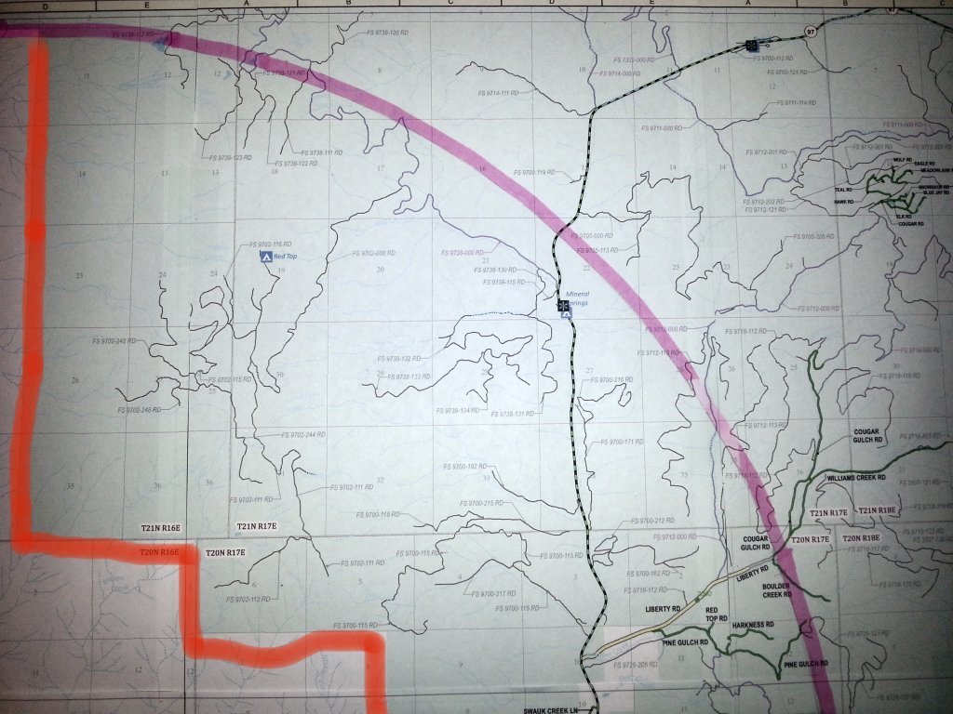
LIBERTY SECTOR MAP 2
